# **EXAMPLE 1. Inverse Distance Weighted Interpolation, IDW**

Suppose we have a local estimation problem of a value at point A in figure 1.1, (Clark, 2001)

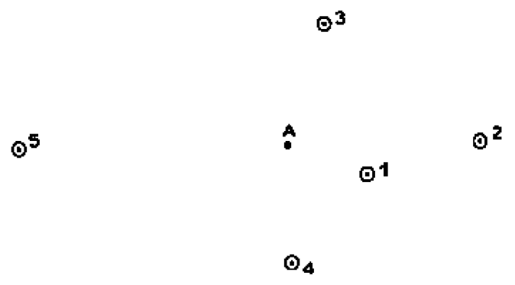

Figure 1.1. Hypothetical situation of sampling and estimation, (Clark, 2001)

To solve this example by applying the non-geostatistical IDW method, schemes such as those shown in figures 1.2 and 1.3 are proposed.

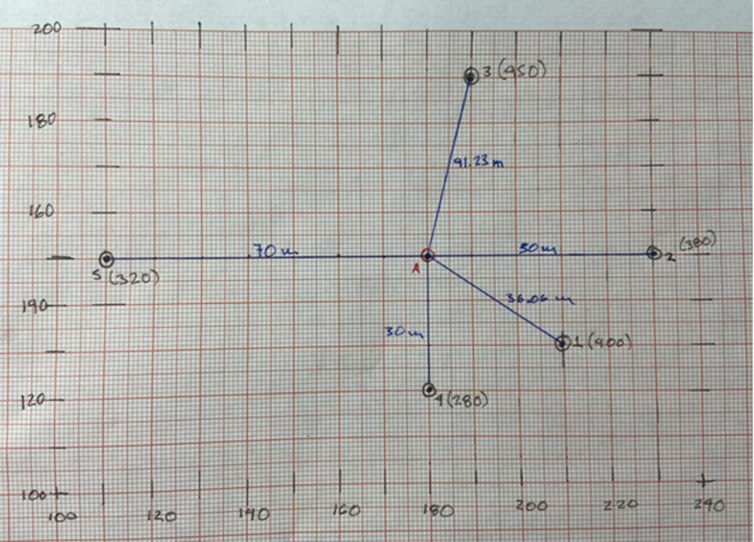

Figure 1.2. Dimensioned diagram of figure 1.1, in m

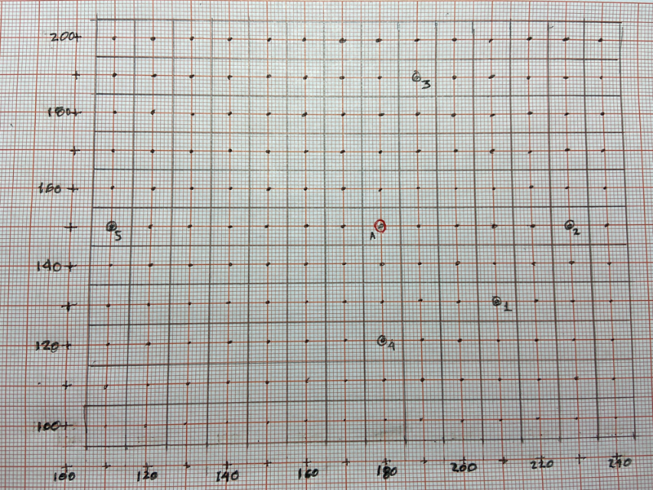

Figure 1.3. Scheme of the mesh for figure 1.1

## **Inverse Distance Weighted Interpolation, IDW. (Bivand, 2013)**

Inverse distance-based weighted interpolation (IDW) computes a weighted average

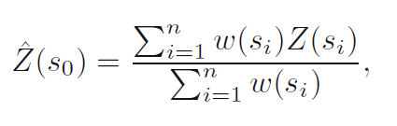

where the weights of the observations are calculated according to their distance from the interpolation location,



where || · || denotes the Euclidean distance and *p* an inverse distance weighting power, with a default value of 2. If *s0* matches an observation location, the observed value is returned to avoid infinite weights.

The power of the inverse distance determines the degree to which closer points are preferred over more distant points; for large values, IDW converges to the nearest neighbor interpolation. It can be adjusted, for example, by cross-validation. IDW can also be used within local search neighborhoods.

Therefore,

***p* = 1;**

$$\overline{A}=\frac{\left(\frac{1}{36.06}∙400\right)+\left(\frac{1}{50}∙380\right)+\left(\frac{1}{41.23}∙450\right)+\left(\frac{1}{30}∙280\right)+\left(\frac{1}{70}∙3200\right)}{{36.06}^{-1}+{50}^{-1}+{41.23}^{-1}+{30}^{-1}+{70}^{-1}}=363.80$$

***p* = 2;**

$$\overline{A}=\frac{\left(\frac{1}{36.06}∙400\right)+\left(\frac{1}{50}∙380\right)+\left(\frac{1}{41.23}∙450\right)+\left(\frac{1}{30}∙280\right)+\left(\frac{1}{70}∙3200\right)}{{36.06}^{-2}+{50}^{-2}+{41.23}^{-2}+{30}^{-2}+{70}^{-2}}=358.26$$

## **Solving with R**

Example_0.csv Grid_Example_0.csv



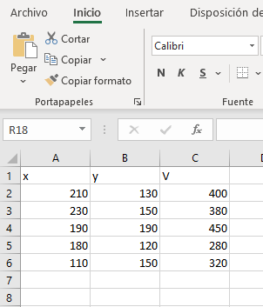

library(sp)

library(gstat)

setwd("C:/Geostatistics/My directory")

# Read data

#

data <- read.csv("Example_0.csv", header=TRUE, sep=",", dec=".")

class(data)

str(data)

attach(data)

coordinates(data) <- c("x", "y") # create a spatial object

# Show data V

plot(x,y,xlim=c(min(x)*0.99,max(x)*1.01),ylim=c(min(y)*.999,max(y)*1.001),pch=3)

text(x+3,y,V)

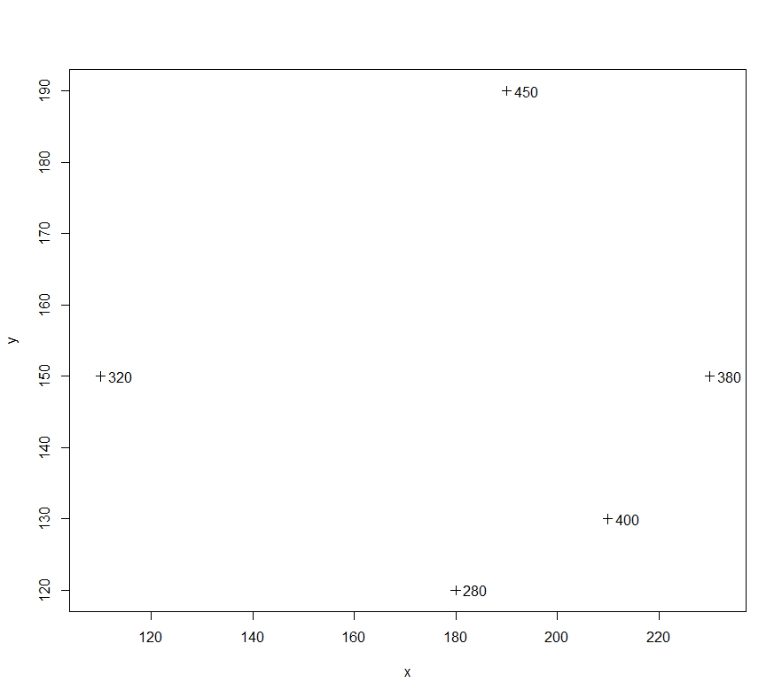

# Reject the null hypothesis if p <= alpha=0.05

# H0: the sample comes from a normally distributed population

shapiro.test(V) # *** Normality ***

qqnorm(V)

qqline(V)

> # Reject the null hypothesis if p <= alpha=0.05

> # H0: the sample comes from a normally distributed population

> shapiro.test(V) # *** Normality ***

Shapiro-Wilk normality test

data: V

W = 0.97671, p-value = 0.9163

# plot methods for spatial data with attributes

# in case of non-normality: spplot(datos, "V", do.log = T, colorkey = TRUE)

spplot(datos, "V", xlab=" V Attribute Scale ", colorkey = F,

key.space=list(x=0.1,y=.95))

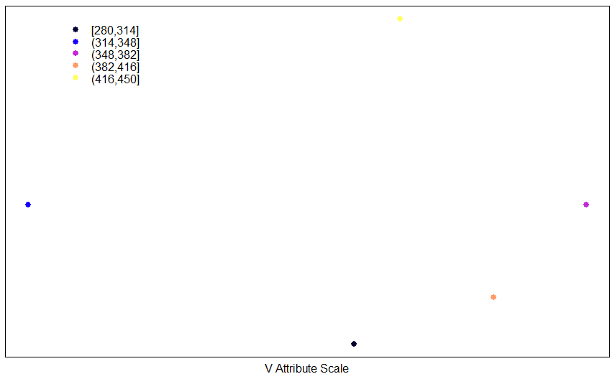

# grid reading

griddata <- read.csv("Grid_Example_0.csv", header=TRUE,sep=",", dec=".")

class(griddata)

str(griddata)

attach(griddata)

coordinates(griddata) <- c("x", "y")

griddata <- as(griddata, "SpatialPixels")

idw.out <- idw(V~1,data, griddata, idp=1)

as.data.frame(idw.out)[1:100,]

idwdata <- as.data.frame(idw.out)

write.csv(idw.out, file = "idw_res.csv") # Save a file .csv

plot(idw.out,axes=T)

idw.out

class(idw.out)

spplot(idw.out,"var1.pred", do.log = F, colorkey = TRUE)

> idw.out <- idw(V~1,data,griddata,idp=1)

[inverse distance weighted interpolation]

> as.data.frame(idw.out)[1:100,]

x y var1.pred var1.var

1 110 100 349.6394 NA

2 110 110 348.0423 NA

1. 110 120 345.7471 NA

...

75 180 140 351.5289 NA

**76 180 150 363.7968 NA**

77 180 160 374.1768 NA

...

> idw.out <- idw(V~1,data,griddata,idp=2)

[inverse distance weighted interpolation]

> as.data.frame(idw.out)[1:100,]

x y var1.pred var1.var

1 110 100 335.2222 NA

2 110 110 332.8073 NA

3 110 120 329.6830 NA

...

75 180 140 331.8761 NA

**76 180 150 358.2615 NA**

77 180 160 382.3909 NA

...

Seen in a plane, with p=2,

plot(x,y,xlim=c(min(x)*0.99,max(x)*1.01),ylim=c(min(y)*.999,max(y)*1.001),pch=3)

text(x,y-2,round(idw.out$var1.pred,2),cex = 0.8)

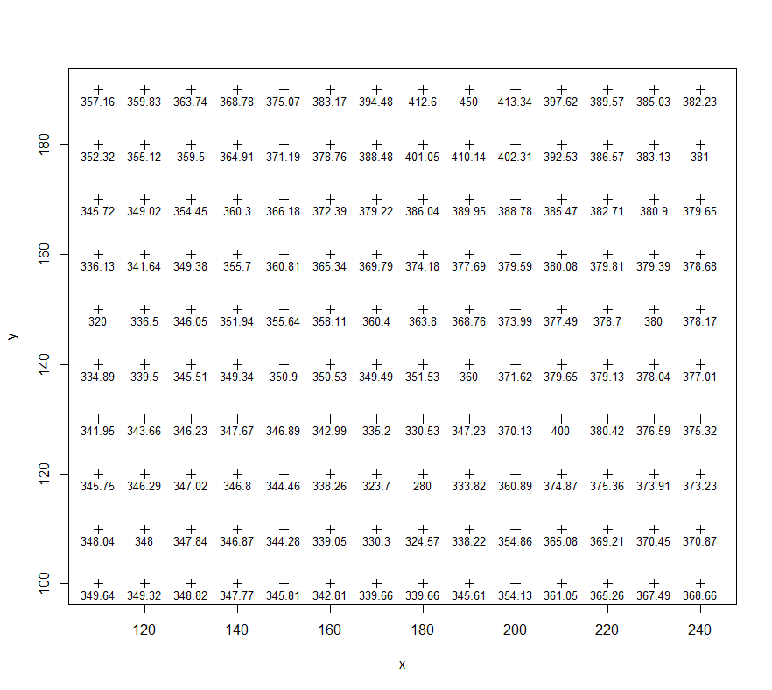

## Conclusions

The similarity between the results of the previous section and the current ones is confirmed.

# **EXAMPLE 2. Introduction to the Variogram**

Figure 2.1 shows a sampling of the average value of the law for Fe (% by weight) in a set of perforations. The aim is to obtain the calculated or experimental semivariogram where *h* depends on the distance between the pair of samples and the relative orientation in a two-dimensional plane. (Clarks, 2001).

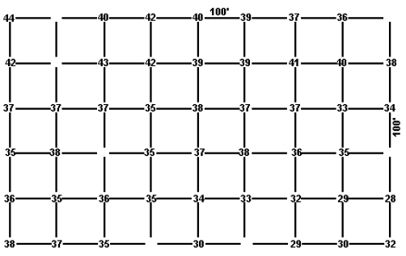

Figure 2.1 Example of data in a grid for the calculation of an experimental semivariogram - iron ore, taken from (Clark, 2001)

Then, to obtain the semivariogram, or variogram, the equation

$$2γ^{*}\left(h\right)=\frac{1}{n}\sum{{\left[g\left(x\right)-g(x+h)\right]}^{2}}$$

where *γ*\*(*h*) is precisely called the experimental semivariogram.

Starting the calculation from east to west, E-W, and with *h* = 100 feet:

$$γ^{*}\left(100\right)=\left[{(40-42)}^{2}+{(42-40)}^{2}+{(40-39)}^{2}+{(39-37)}^{2}+{(37-36)}^{2}+{(43-42)}^{2}+{(42-39)}^{2}+{(39-39)}^{2}+{(39-41)}^{2}+{(41-40)}^{2}+{(40-38)}^{2}+{(37-37)}^{2}+{(37-37)}^{2}+{(37-35)}^{2}+{(35-38)}^{2}+{(38-37)}^{2}+{(37-37)}^{2}+{(37-33)}^{2}+{(33-34)}^{2}+{(35-38)}^{2}+{(35-37)}^{2}+{(37-38)}^{2}+{(38-36)}^{2}+{(36-35)}^{2}+{(36-35)}^{2}+{(35-36)}^{2}+{(36-35)}^{2}+{(35-34)}^{2}+{(34-33)}^{2}+{(33-32)}^{2}+{(32-29)}^{2}+{(29-28)}^{2}+{(38-37)}^{2}+{(37-35)}^{2}+{(29-30)}^{2}+{(30-32)}^{2}\right]÷(2+36)=1.42 (\%)^{2}$$

This provides a point that we can plot on a plot of the experimental semivariogram (*γ*\*) versus the distance between samples (*h*), ie [100 ft, 1.42 (%)2]. Figure 2.2 outlines the calculation procedure.

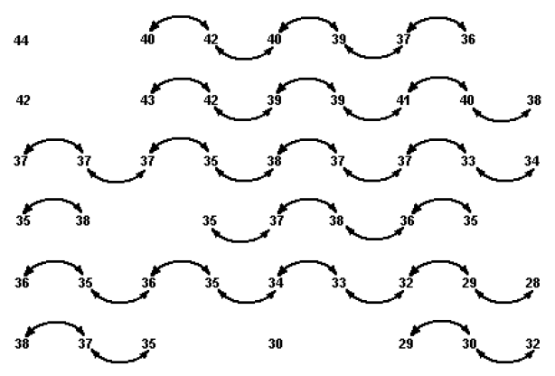

Figure 2.2. Identification of all pairs of sampling points within 100 feet of each other, in an east-west, E-W direction. (Clarks, 2001)

Now with *h* = 200 feet,

$$γ^{*}\left(200\right)=\left[{(44-40)}^{2}+{(40-40)}^{2}+{(42-39)}^{2}+{(40-37)}^{2}+{(39-36)}^{2}+{(42-43)}^{2}+{(43-39)}^{2}+{(42-39)}^{2}+{(39-41)}^{2}+{(39-40)}^{2}+{(41-38)}^{2}+{(37-37)}^{2}+{(37-35)}^{2}+{(37-38)}^{2}+{(35-37)}^{2}+{(38-37)}^{2}+{(37-33)}^{2}+{(37-34)}^{2}+{(38-35)}^{2}+{(35-38)}^{2}+{(37-36)}^{2}+{(36-35)}^{2}+{(36-36)}^{2}+{(35-35)}^{2}+{(36-34)}^{2}+{(35-33)}^{2}+{(34-32)}^{2}+{(33-29)}^{2}+{(32-28)}^{2}+{(38-35)}^{2}+{(35-30)}^{2}+{(30-29)}^{2}+{(29-32)}^{2}\right]÷(2+33)=3.55 (\%)^{2}$$

Figure 2.3 shows the schematic calculation procedure.

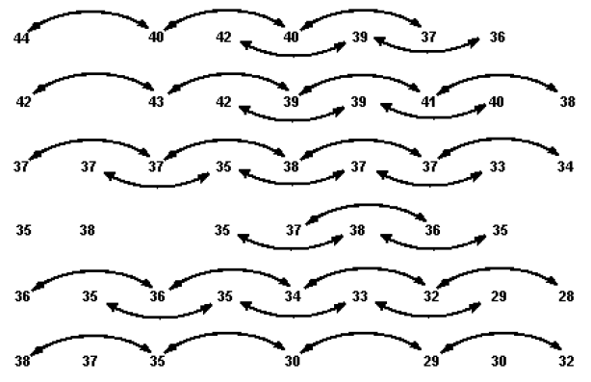

Figure 2.3. Identification of all pairs of sampling points within 200 feet of each other, in an east-west, E-W direction. (Clarks, 2001)

Table 2.1 summarizes the results obtained for the two main directions, considering distances up to half of the maximum extension in both directions, and figure 2.4 shows the graph of the corresponding semivariograms.

|  |  |  |  |
| --- | --- | --- | --- |
| Dirección | Distancia entre muestras (feet) | Semivariograma experimental | Número de pares |
| E-O | 100  200  300  400 | 1.42  3.55  3.54  6.61 | 36  33  26  23 |
| N-S | 100  200  300  400 | 5.26  9.06  16.21  25.54 | 35  27  21  13 |

Table 2.1 Calculation of Experimental Semivariogram Values in Two Principal Directions for the Square Grid Iron Ore Example

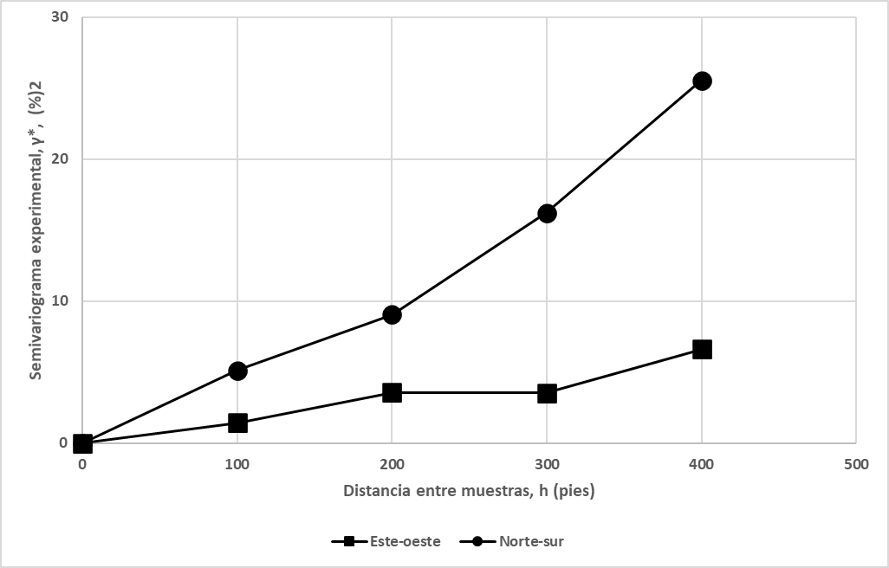

Figure 2.4 Experimental semivariograms in the two principal directions for the iron ore example.

## **Conclusions**

As can be seen, there appears to be a distinct difference in structure in the two directions (anisotropy). The N-S semivariogram rises much more sharply than the E-W, suggesting greater continuity in the E-W direction. This can be verified by calculating the semivariogram in diagonal directions, for example Northwest-Southeast, NW-SE, and Northeast-Southwest, NE-SW. For this, the *h* will take values of 141.42, 282.84 and 424.26 feet. Table 2.2 shows the results and figure 2.5 shows the behavior of all the calculated semivariograms E-W, N-S and diagonals NW-SE and NE-SE.

The *γ*\* in both diagonal directions seems to confirm the difference between the other two principals, since they lie between them; although the N-S of the NW-SE and the E-W of the NE-SW seem to be closer. In addition, considering that the fewer pairs there are, the less reliable the calculations are, it would be necessary to evaluate the reliability of the experimental semivariograms in the direction of the diagonals, since they were calculated with 14 pairs only in 424 feet.

|  |  |  |  |
| --- | --- | --- | --- |
| Direction | Distance between samples (feet) | Experimental semivariogram | Number of pairs |
| Northwest-Southeast Diagonal  Northeast-Southwest Diagonal | 141  283  424  141  283  424 | 7.31  13.14  28.21  3.60  5.43  7.64 | 32  21  14  31  22  14 |

Table 2.2. Calculation of the semivariogram in the diagonal direction for iron ore.

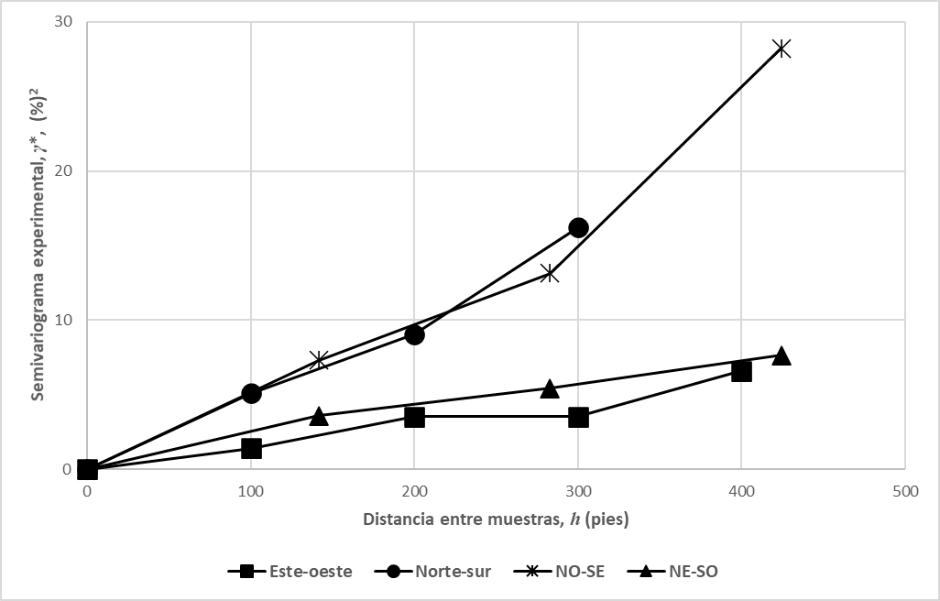

Figure 2.5. Experimental semivariograms including in diagonal direction for iron ore

Also, if a straight line is fitted to the semivariograms, the E-W slope would be 0.0153 (%)2/ft, that is, approximately *γ*(*h*) = 0.0153h (%)2. In N-S direction it would be 0.0524 (%)2 /ft, *γ*(*h*) = 0.0524*h* (%)2, in NW-SE direction 0.064 (%)2 /ft, *γ*(*h*) = 0.064*h* (%)2 and in NE-SW direction 0.0175 (%)2 /ft, *γ*(*h*) = 0.0175*h* (%)2. That is, in the E-W direction, a squared difference of 0.0153 (%)2 is "expected" for each foot between the samples. Stated another way, a difference in grade of 0.0153 = 0.1237% Fe is expected for two samples 1 foot apart, with an E-W relative orientation; in the N-S direction, the corresponding figure is 0.2289% Fe. For samples 100 feet apart, differences of 1.237% Fe (E-O) and 2.2289% Fe (N-S) would be expected, and so on. With these observations it can be verified that there is similarity in the behavior of the Fe law in the N-S and NW-SE directions, as well as in the E-W and NE-SO directions. Therefore, a picture of the grade fluctuations within this section of the deposit has been created and a fairly simple model has been created to describe the differences in grade in the selected directions.

## **Solving with R**

library(sp)

library(gstat)

setwd("C:/Geoestadistics/My Directory")

# Read the data

#

datos <- read.csv("Example_11.csv", header=TRUE, sep=",", dec=".")

*Example_11.csv*

 

# view z-data

plot(x,y,xlim=c(min(x)*0.99,max(x)*1.01),ylim=c(min(y)*.999,max(y)*1.001),pch=3)

text(x+20,y,z)

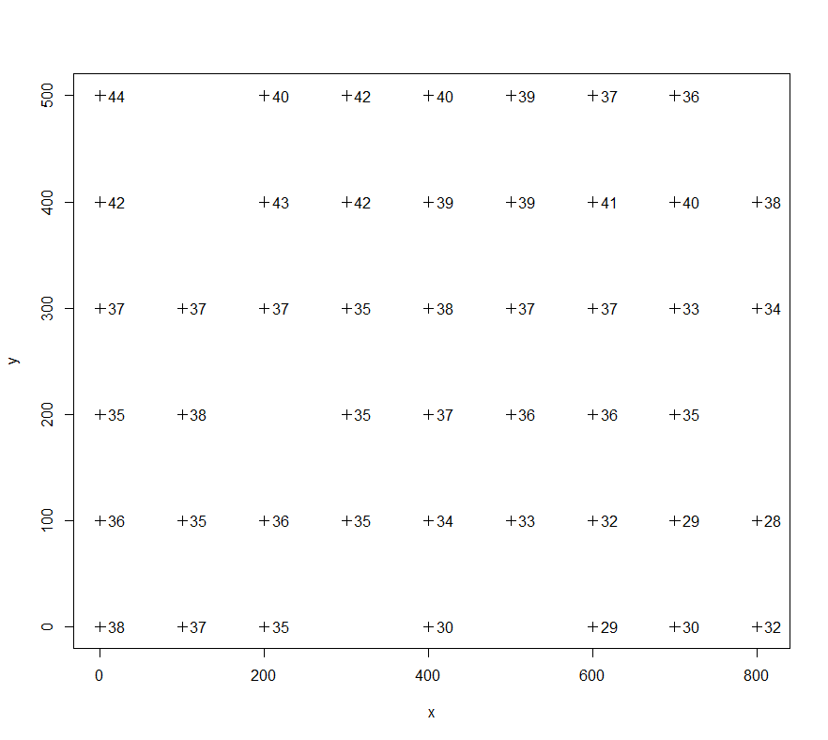

> summary(z) # Similar median an mean

Min. 1st Qu. Median Mean 3rd Qu. Max.

28.00 35.00 37.00 36.34 38.50 44.00

> # H0: the sample comes from a normally distributed population

> # Reject the null hipótesis if p <= alpha=0.05

> shapiro.test(z) # *** Normality ***

Shapiro-Wilk normality test

data: z

W = 0.97355, p-value = 0.3593

# EXPLORATION OF ATTRIBUTES

#

hist(z,breaks=10) # Somewhat symmetric distribution

summary(z) # Similar median and mean

# H0: the sample comes from a normally distributed population

# Reject the null hypothesis if p <= alpha=0.05

shapiro.test(z) # *** Normality ***

qqnorm(z)

qqline(z)

# Estimate spatial correlation: variogram

coordinates(datos) <- c("x", "y") # create spatial data frame

hscat(z~1,datos,(0:8)*100)qqline(z) # generally the smaller h, the better the correlation

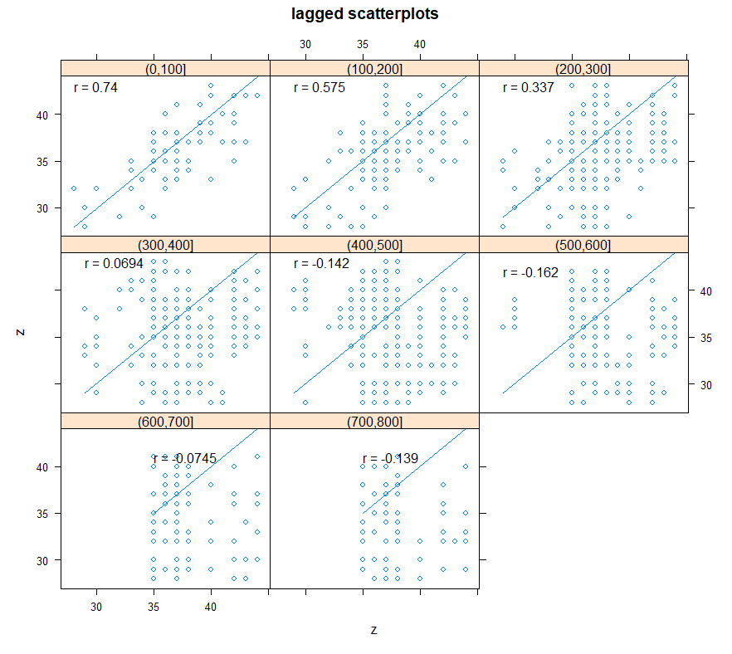

# Another visualization with proportional symbols.

# bubble chart

plot(datos, asp=1, cex = 3*z/max(z), pch=1, axes=T)

text(x+20,y,z, cex=0.8)

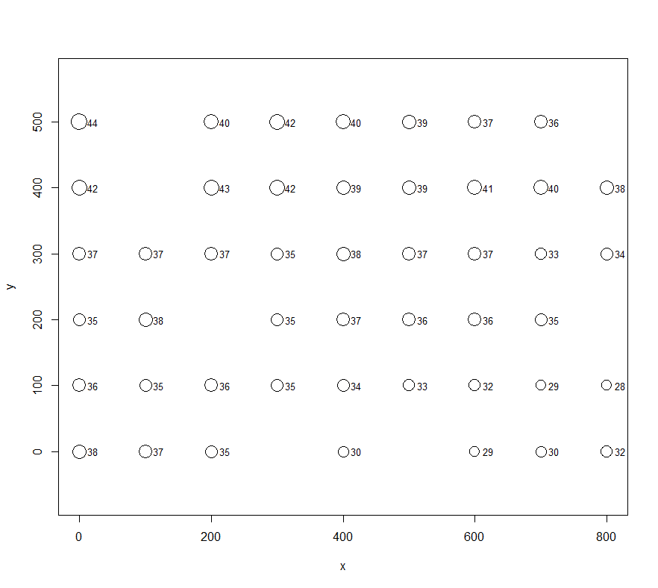

[1] 47

> n*(n+1)/2

[1] 1128

# LOCAL SPATIAL STRUCTURE: AUTOCORELATION

#

class(datos)

str(datos) # SLot @proj4string does not have the reference system assigned.

# calculates how many pairs of points there are in dataset data.

n <- length(z)

n

n*(n+1)/2

> # LOCAL SPATIAL STRUCTURE: AUTOCORELATION

> #

> class(datos)

[1] "SpatialPointsDataFrame"

attr(,"package")

[1] "sp"

> str(datos) # SLot @proj4string does not have reference system assigned.

Formal class 'SpatialPointsDataFrame' [package "sp"] with 5 slots

..@ data :'data.frame': 47 obs. of 1 variable:

.. ..$ z: int [1:47] 44 42 37 35 36 38 37 38 35 37 ...

..@ coords.nrs : int [1:2] 1 2

..@ coords : num [1:47, 1:2] 0 0 0 0 0 0 100 100 100 100 ...

.. ..- attr(*, "dimnames")=List of 2

.. .. ..$ : NULL

.. .. ..$ : chr [1:2] "x" "y"

..@ bbox : num [1:2, 1:2] 0 0 800 500

.. ..- attr(*, "dimnames")=List of 2

.. .. ..$ : chr [1:2] "x" "y"

.. .. ..$ : chr [1:2] "min" "max"

..@ proj4string:Formal class 'CRS' [package "sp"] with 1 slot

.. .. ..@ projargs: chr NA

To compare with the results in Figure 2.5,

# EXPERIMENTAL EMPIRICAL VARIOGRAM

#

ve <- variogram(z~1,data,alpha=c(0,45,90,135),cutoff=500,width=100)

ve

plot(ve, plot.numbers = T,main = "Example 1", xlab = "Distance",

ylab = "Semivariance", asp=1, type="l")

> ve

np dist gamma dir.hor dir.ver id

1 36 100.0000 5.347222 0 0 var1

2 27 200.0000 9.870370 0 0 var1

3 21 300.0000 18.880952 0 0 var1

4 50 338.0085 19.900000 0 0 var1

5 28 427.9694 28.660714 0 0 var1

6 31 141.4214 3.887097 45 0 var1

7 74 241.2175 5.013514 45 0 var1

8 37 360.5551 8.094595 45 0 var1

9 62 459.9107 8.443548 45 0 var1

10 36 100.0000 1.458333 90 0 var1

11 33 200.0000 3.303030 90 0 var1

12 27 300.0000 4.314815 90 0 var1

13 71 343.3653 6.408451 90 0 var1

14 57 438.4636 8.315789 90 0 var1

15 32 141.4214 7.062500 135 0 var1

16 76 239.9746 10.006579 135 0 var1

17 34 360.5551 22.132353 135 0 var1

18 58 459.3618 32.655172 135 0 var1

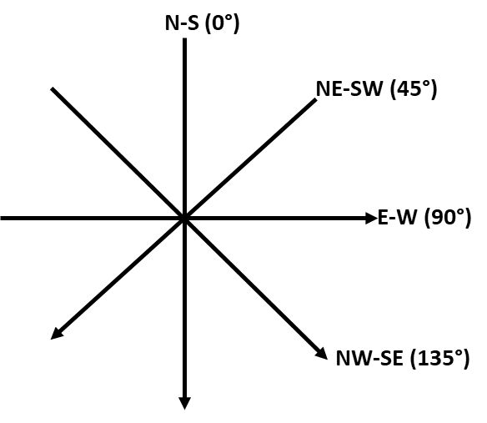

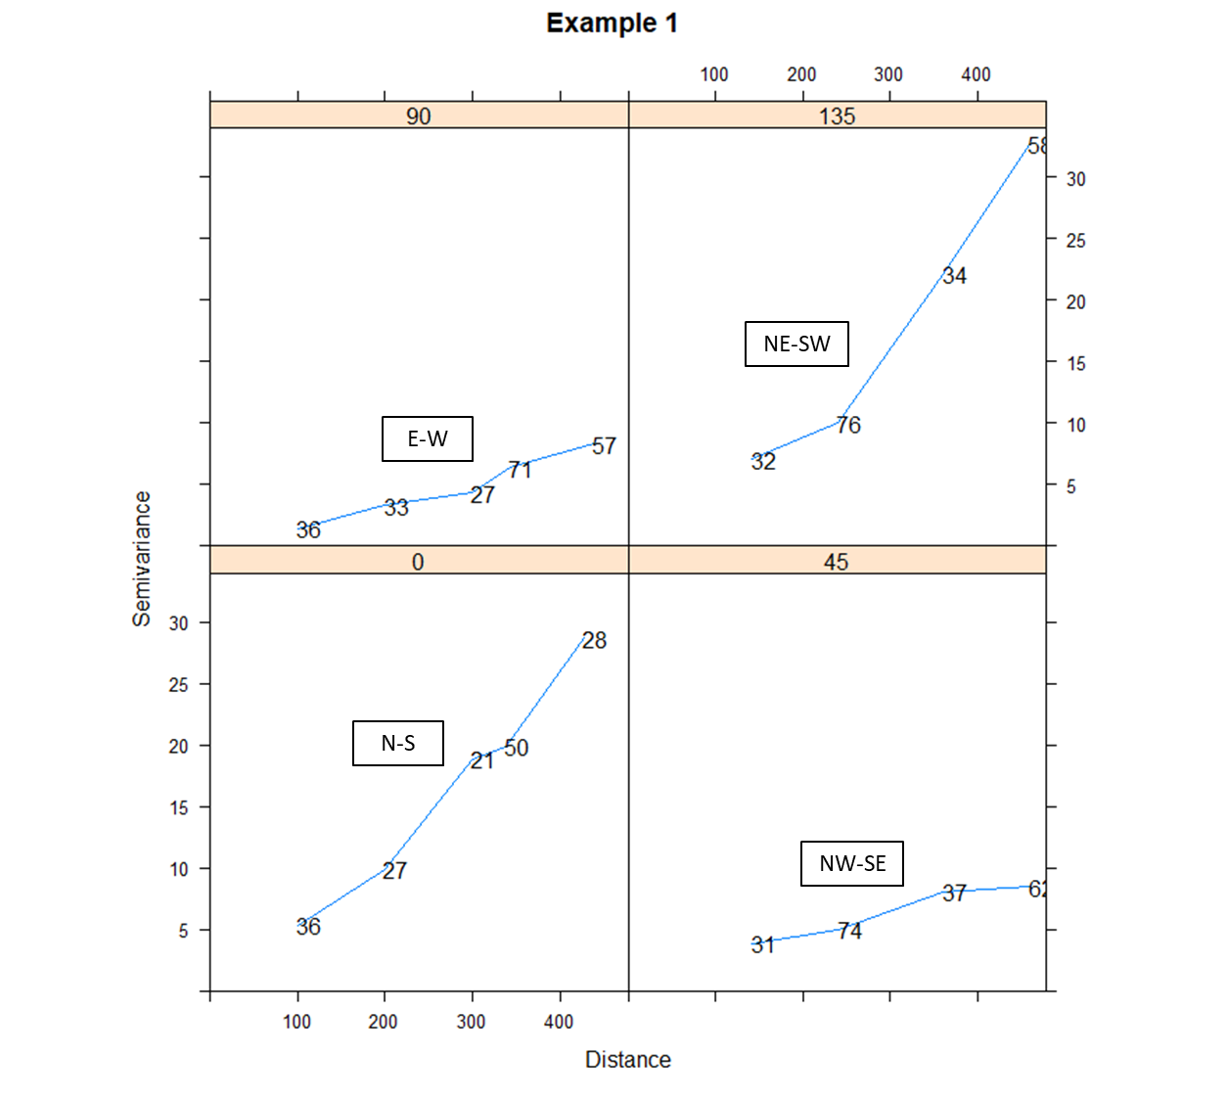

## Conclusions

The similarity with what was described in the previous conclusions is confirmed: similar behavior in the N-S and NE-SW directions, as well as in the E-W and NW-SE directions.

# **References**

Bivand, R. P. (2013). *Applied Spatial Data Analysis witu R.* New York: Springer-Science+Business.

Clark, I. (2001). *Practical Geostatistics.* Central Scotland: Alloa Business Centre.